Sec. 30-4.8. Development compatibility.

A. *Setbacks.*

1. Whenever a zero foot setback is allowed in a zoning district, it may only be used if the abutting property is within a district that allows the same setback.

2. The minimum required side and rear setback for nonresidential buildings located on property abutting a single-family zoning district shall be the same as the setback required on the adjacent residential lot or as determined by the required buffer, whichever is greater.

B. *Limitations on uses.* All industrial or commercial activity and uses, except storage of equipment and parking, shall be conducted within completely enclosed buildings when located within 300 feet of any property that is in a single-family zoning district.

C. *Building height and massing.*

|  |  |  |  |
| --- | --- | --- | --- |
| **Within 100' of the Following Districts:** | **Max. Building Height** | | |
| Single-Family Zoning | 3 stories and 36' | Building facades shall not exceed 60' unless a substantial volume break is provided, such as a volume recess with a minimum 10' depth. | |
|  | • Measured to the roof peak with a hip, gable, mansard or similar roof where the 3rd floor is above the roof line, or |
| Historic District (except University Heights-South) |
|  | • Measured to the top plate of the 3rd floor with a flat or similar roof. |
| University Heights-South Historic District | 4 stories and 60' | | |
| • Measured to the top plate of the 4th floor. | | |
| **Within the Following Districts:** | **Max. Building Height** | | |
| Pleasant Street Historic District | 3 stories and 36' | | |
| Power District | 6 stories, but  3 stories when adjacent to residential zoning, with a step-back of 15' per additional building story up to max. permitted. | | |

Figure 1: Height Compatibility Pitched Roof Example

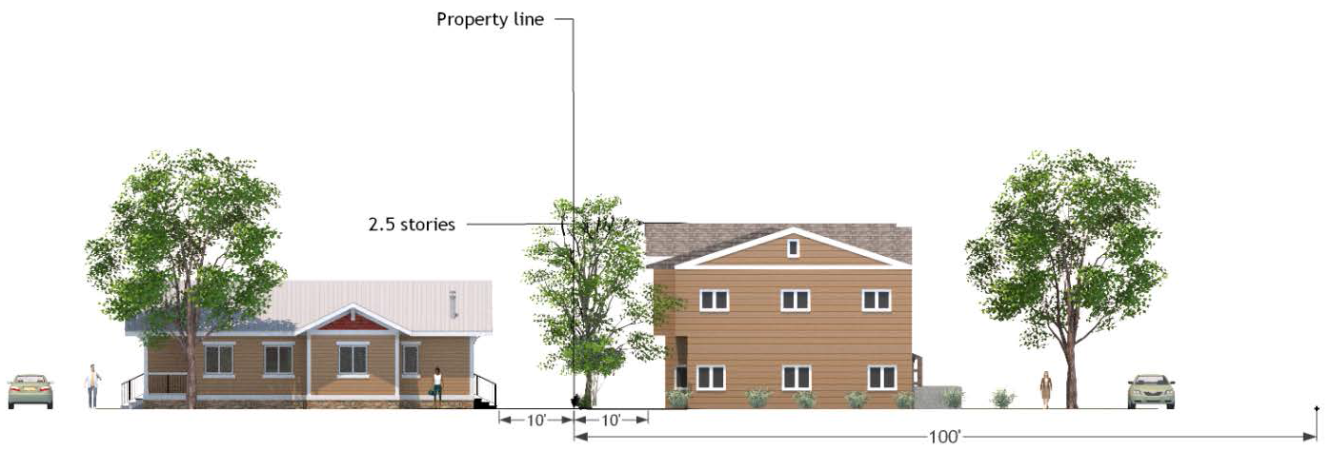

Figure 2: Height Compatibility Flat Roof Example

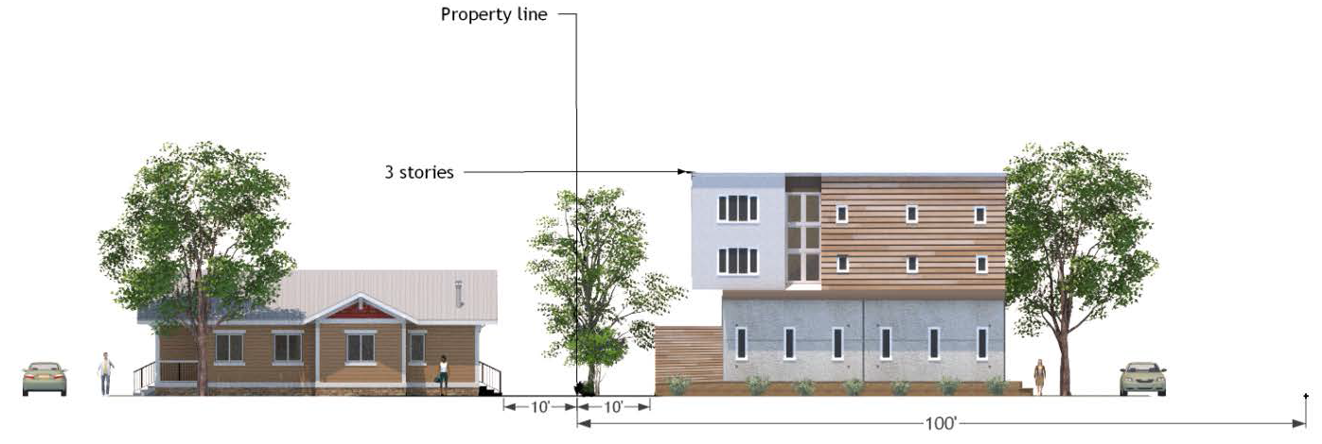

Figure 2: Height Compatibility University Heights

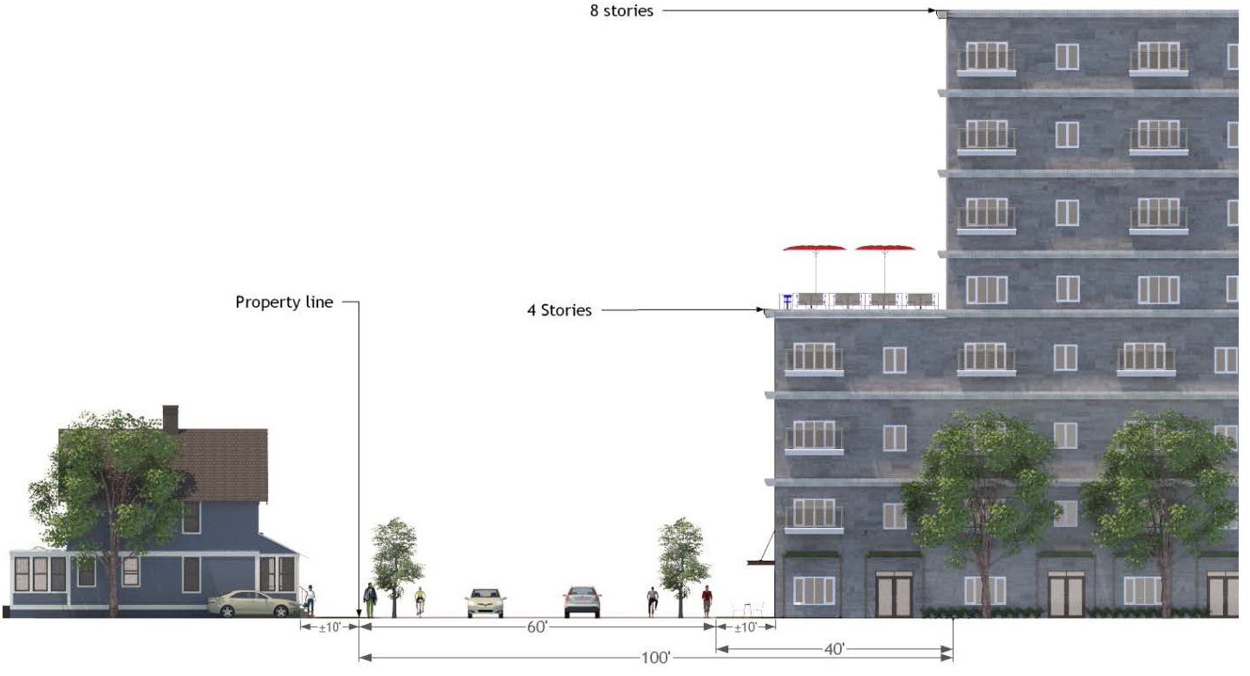

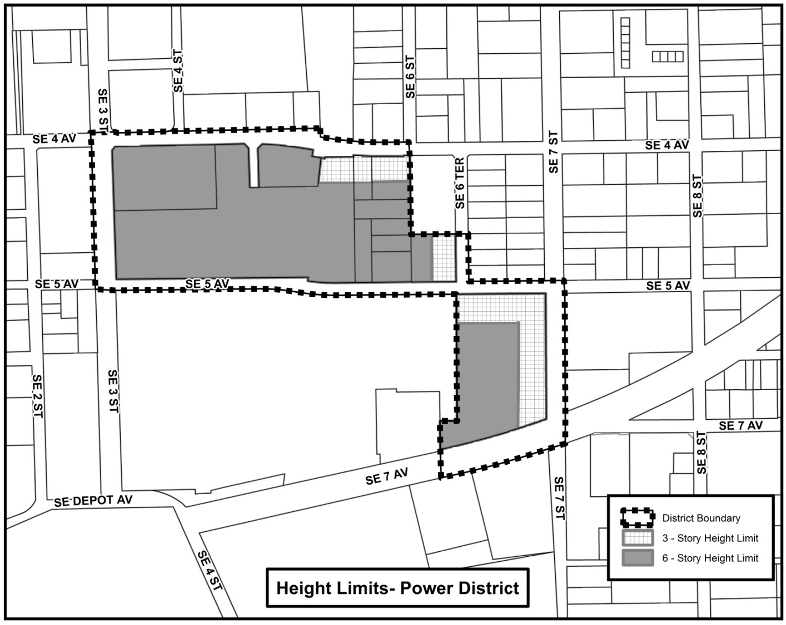

D. *Multi-family developments.*

1. *Generally.* Multi-family development shall contain no more than six dwelling units per building and shall be in the form of single-family dwellings, attached dwellings, or small-scale multi-family when located within 100 feet of any property that is in a single-family zoning district, the U1 district, or a designated historic district.

2. *Abutting single-family property.* All new multi-family projects, whether stand alone or part of a mixed-use project, abutting property in a residential district or a planned development district with predominantly residential uses shall comply with the following regulations:

a. There shall be no outdoor recreation areas or uses allowed within any required building setback area or landscape buffer between abutting multi-family development and single-family designated properties.

b. Active recreation areas (including swimming pools, tennis courts, basketball, and volleyball courts) shall be located away from abutting single-family designated properties and shall be oriented in the development to minimize noise impacts on single-family designated properties.

c. There shall be no car washing areas, dumpsters, recycling bins, or other trash/waste disposal facilities placed in the required setback area between multi-family development and properties zoned for single-family use.

d. Parking lots and driveways located in the area between multi-family and abutting single-family designated properties shall be limited to a single-loaded row of parking and a two-way driveway.

e. A decorative masonry wall (or equivalent material in noise attenuation and visual screening) with a minimum height of six feet and a maximum height of eight feet plus a Type B landscape buffer shall separate multi-family residential development from properties designated single-family residential. However, driveways, emergency vehicle access, or pedestrian/bicycle access may interrupt a continuous wall. If, in the professional judgment of city staff or other professional experts, masonry wall construction would damage or endanger significant trees or other natural features, the appropriate reviewing authority may authorize the use of a fence and/or additional landscape buffer area to substitute for the required masonry wall. There shall be no requirement for a masonry wall or equivalent if buildings are 200 or more feet from abutting single-family properties. In addition, the appropriate reviewing authority may allow an increased vegetative buffer and tree requirement to substitute for the required masonry wall.

f. The primary driveway access shall be on a collector or arterial street, if available. Secondary ingress/egress and emergency access may be on or from local streets.

(Ord. No. 170974, § 5, 2-21-19; Ord. No. 211359, § 4, 10-17-22; Ord. No. 2023-169, § 4, 6-1-23)

Sec. 30-4.9. Development bonus system.

A. *Available bonuses.* In accordance with this section, development projects may be eligible for: 1) additional increase in overall building height; and 2) increased residential density. The bonus may be approved based on the provision of certain development improvements that exceed the minimum standards of this article, as follows:

B. *Additional building stories/height.*

1. *Usable open space.* If a development provides onsite usable open space that is accessible to the public (minimum size of 20' × 20'), additional building square footage above the height allowed by right may be provided according to the following formula:

Square feet of public open space X number of feet allowed by right divided by ten = additional square feet. If the total additional square footage meets or exceeds 20% of the total development site, additional 15’ is available. If the total additional square footage meets or exceeds 30% of the total development site, 30’ are available.

Developments receiving a height bonus must provide at least one form of open space from the figures and associated standards below:

|  |  |
| --- | --- |
| **Green** | 30-4-9green.png |
| A green is an open space for unstructured recreation. Greens consist of lawns, trees, paths, benches, and open shelters, all informally arranged. |
| 1. Greens may be spatially defined by landscaping rather than building frontages. |
| 2. Greens must front on at least two streets. |
| **Square** | 30-4-9Square.png |
| A square is an open space for recreation and civic purposes consisting of paths, lawns, and trees, all formally arranged. A square is spatially defined by abutting streets and building frontages. |
| 1. Squares shall be located at the intersections of important thoroughfares. |
| 2. Squares must front on at least 3 streets. |
| 3. Façades facing the square should have at least 40% of their first floor's primary façade in transparent windows. |
| **Plaza** | 30-4-9Plaza.png |
| An open space for commercial and civic purposes consisting primarily of paved surfaces. A plaza is spatially defined by building frontages. |
| 1. Plazas should be located at the intersection of important streets. |
| 2. Plazas must front on at least one street. |
| 3. Façades facing the plaza should have at least 40% of their first floor's primary façade in transparent windows. |
| **Playground** | 30-4-9Playground.png |
| A fenced open space designed and equipped for the recreation of children. |
| 1. Playgrounds shall be located within ¼ mil surrounding neighborhoods. |
| 2. Playgrounds may be freestanding or located within parks and greens. |
| **Pocket Plaza** | 30-4-9PocketPlaza.png |
| A formal open space available for civic purposes and commercial activities. Pocket Plazas are typically hardscaped and include landscaping in lawns or permanent planters. |
| 1. Pocket plazas should be located on side streets. |
| 2. Pocket Plazas must front on at least one street. |
| 3. Pocket Plazas may be used to provide seating for outdoor cafes or similar publicly accessible gathering space. |
| **Promenade** | 30-4-9-Promenade.png |
| A linear pedestrian open space between streets that extends through successive blocks. The space largely hardscaped and lined with trees at the edges. |
| 1. Promenades must be a minimum of 16' wide. |
| 2. Promenades may include outdoor seating or other similar public amenities. |

2. *Tree preservation.* If a development dedicates an area onsite to preserve one or more heritage trees, the additional building square footage above the number of feet allowed by right may be provided according to the following formula:

Square feet of tree preservation area X number of feet allowed by right divided by 10 = additional square feet. If the total additional square feet meets or exceeds 20 percent of the total development site, 15’ additional story is available. If the total additional square footage meets or exceeds 30 percent of the total development site, 30’ are available.

3. *Structured parking.* Within transect zones, up to two levels of parking that are constructed within a habitable building are not counted as stories for the purposes of calculating the total number of stories, provided the footprint of the parking structure falls within 75 percent to 100 percent of the footprint of the habitable floors directly above the parking levels.

4. *Transit support facilities.* If a development provides onsite facilities, beyond what otherwise is required, to serve existing or planned public transit, including but not limited to bus bays, covered bus stops, bus stations, bus lanes, and park and ride lots, 15’ is available.

5. *Undergrounding/relocating utility lines.* If a development undergrounds overhead utility lines beyond what otherwise is required, or relocates existing underground lines in order to facilitate the appropriate placement of street trees or buildings along streets, up to 30’ is available for every street segment completed (from intersection to intersection); 15’ is available for the undergrounding/relocation of utilities along the street frontage of the development.

C. *Increased residential density.*

1. *Tree preservation.*

|  |  |  |  |  |
| --- | --- | --- | --- | --- |
| **RESIDENTIAL DENSITY BONUS** | | | | |
| High Quality Heritage Tree Preservation (fair or better condition): | | | | |
| Tree DBH | 20"—30" | 31"—50" | 51"—70" | 71"+ |
| Bonus DU/Acre (whichever is greater) | 1 or 1% | 2.5 or 2.5% | 5 or 5% | 10 or 10% |
| Regulated Tree Cluster Preservation (fair or better condition): | | | | |
| Number of trees in cluster | 3—5 | 6—8 | 9—11 | 12+ |
| Bonus DU/Acre (whichever is greater) | 1 or 1% | 2.5 or 2.5% | 5 or 5% | 10 or 10% |

The city manager or designee may grant a density bonus for preserving tree clusters that, in his or her discretion, reasonably meet the following standards:

a. Species within the cluster must be on the Gainesville Tree List.

b. Trees within a cluster must have a minimum average DBH of 8 inches.

c. Trees within a cluster must be sufficiently spaced as to not have overlapping root plates.

d. Laurel oaks, water oaks, slash pines, and loblolly pines may not be included as part of a cluster.

2. *Affordable housing.* The city manager or designee may grant a density bonus for the provision of affordable housing units or payment-in-lieu in accordance with division 6 of article IV of this chapter.

D. *Review and approval.* Each request for a bonus is subject to the approval of the city manager or designee, based on the criteria outlined above in this section.

E. *Maximum allowable density bonuses.* The total density bonuses available to a development may not exceed a 50 percent increase over applicable available density by right.

(Ord. No. 170971, § 1, 2-21-19; Ord. No. 2022-679, § 3, 9-19-24)

Editor's note(s)—Ord. No. 170971, § 1, adopted February 21, 2019, amended § 30-4.9 in its entirety to read as herein set out. Former § 30-4.9, pertained to building height bonus system. See Code Comparative Table for complete derivation.